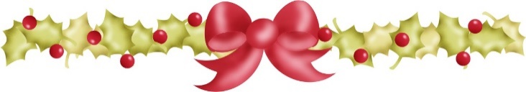

Letters from Santa

Please complete as much of the form as you wish to share about the child who will receive a letter. Santa and Mrs: Claus do not share this information with anyone. It is strictly confidential. However, we understand if you may not want to complete every question.
Santa’s letters never say negative things to a child or threaten them with the Naughty List or lumps of coal. Naughty children do not exist in Santa’s world. Please note that Santa’s letters are non-religious.
You can either mail the completed form to the address listed below in the payment section or email it as an attachment to dpartlow130@gmail.com
Letter-writing begins upon receipt of the completed form and payment. Your child’s letter normally will be sent out within three days. Delivery in the local area usually takes two-three days. Letters will arrive via the U.S. Postal Service.
Santa’s letters arrive in a bright red or green manilla envelope and are usually one page long, occasonally two. Included is a Nice List certificate for your child and a small surprise.
Payment:
Payment can be made via Paypal or check at the time you order a Santa letter. Letters cost $30 apiece. Santa letters are non-refundable, since Santa normally begins writing your child’s letter as soon as it is received.
Checks, made out to Claus, Claus & Associates, should be sent with the completed order form to:
Claus, Claus & Associates
c/o Deanna Partlow
2215 Fir St SE
Olympia WA 98501

Paypal payment should be directed to either: 360-789-5420 or to dpartlow130@gmail.com
Deadline: To insure delivery before Christmas, orders must be received by Dec. 10, or by Dec. 14, if the letter is being sent to a child in Western Washington/Oregon.
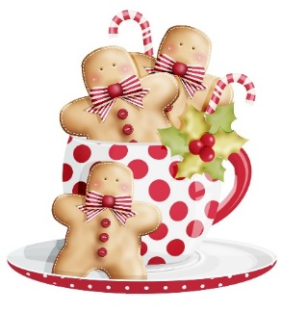
Santa’s contact information:
Deanna or Bob Partlow
Dpartlow130@gmail.com / 360-539-7863 (please leave a message if we’re away from the phone).

Thank you for this opportunity to make your child’s holidays extra special. We hope she or he will enjoy it!
Letters to Santa Form

- Person ordering the letter:
- Your contact phone number and email address; and best time to reach you.

- Name and address where the completed letter should be sent:

- First and last name of the child (include a nickname if the child goes by it) and their age:

- Names and ages of brothers/sisters:

- Top three items the child wants for Christmas:
(Note: if the child is requesting a pet, let Santa know if he/she will be receiving a new pet at Christmas. If the child won’t be getting a new pet, Santa will make an excuse and suggest an alternative, usually a stuffed pet. Similarly, if an expensive item like a game system or computer is requested and that isn’t possible this year, let Santa know.)

- Grade in school and name of school child attends:

- Teacher’s name:
- Most challenging subject:

- Favorite subject(s) or favorite things about school:

- Pets’ names and what type animals they are:

- Favorite activities or what child excels at (dance, sports, reading, etc.):

- Something the child does well, like picking up toys or being nice to a sister or brother:

- Something the child needs to improve on:

- Does the child have an elf-on-the-shelf or similar? If so, include the name:

- Something the child is especially looking forward to this Christmas – or that they love about Christmas;

- Does the child have any specific challenges that should be addressed in this letter? For instance, is he or she ill or suffering from a recent loss this year? If so, Santa will write something reassuring and encouraging:

